Инструкция выполнения: Выполнить перевод текста «Clutch». Выполненное задание предоставить преподавателю Королевой Александре Андреевне на адрес электронной почты. Эл.почта: evseeva14alex@gmail.com. Работа может быть выполнена в формате txt, doc, docx или фотография, выполненной работы на бумажном носителе.

Clutch
A clutch is a mechanical device which engages and disengages power transmission especially from driving shaft to driven shaft.
In the simplest application, clutches connect and disconnect two rotating shafts (drive shafts or line shafts). In these devices, one shaft is typically attached to an engine or other power unit (the driving member) while the other shaft (the driven member) provides output power for work. While typically the motions involved are rotary, linear clutches are also possible.
In a torque-controlled drill, for instance, one shaft is driven by a motor and the other drives a drill chuck. The clutch connects the two shafts so they may be locked together and spin at the same speed (engaged), locked together but spinning at different speeds (slipping), or unlocked and spinning at different speeds (disengaged).
The vast majority of clutches ultimately rely on frictional forces for their operation. The purpose of friction clutches is to connect a moving member to another that is moving at a different speed or stationary, often to synchronize the speeds, and/or to transmit power. Usually, as little slippage (difference in speeds) as possible between the two members is desired.
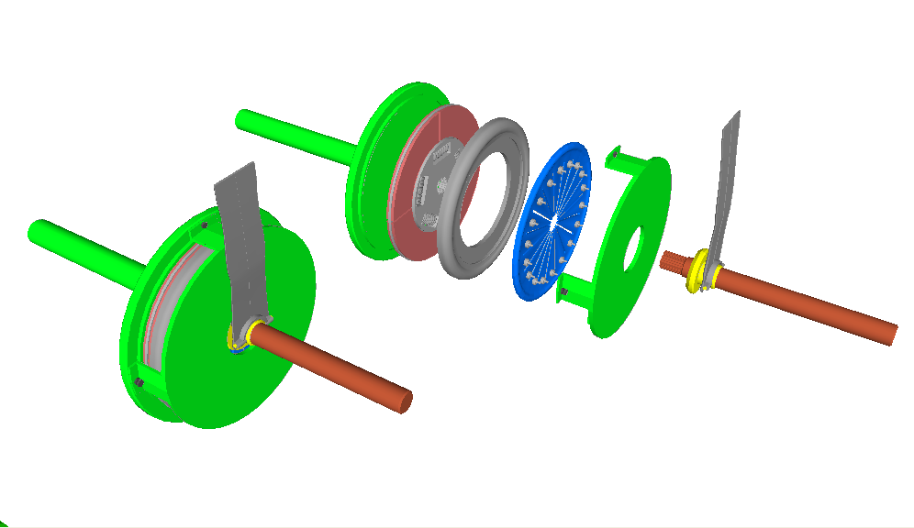
A friction clutch
Materials
Various materials have been used for the disc-friction facings, including asbestos in the past. Modern clutches typically use a compound organic resin with copper wire facing or a ceramic material. Ceramic materials are typically used in heavy applications such as racing or heavy-duty hauling, though the harder ceramic materials increase flywheel and pressure plate wear.
In the case of "wet" clutches, composite paper materials are very common. Since these "wet" clutches typically use an oil bath or flow-through cooling method for keeping the disc pack lubricated and cooled, very little wear is seen when using composite paper materials.
Push/pull
Friction-disc clutches generally are classified as push type or pull type depending on the location of the pressure plate fulcrum points. In a pull-type clutch, the action of pressing the pedal pulls the release bearing, pulling on the diaphragm spring and disengaging the vehicle drive. The opposite is true with a push type, the release bearing is pushed into the clutch disengaging the vehicle drive. In this instance, the release bearing can be known as a thrust bearing (as per the image above).

